

**Cégep de la Gaspésie et des Îles,**

**Montréal**

**A Project Report on**

# Covid Application



**Submitted by**

|  |  |  |
| --- | --- | --- |
| **S.No** | **Student Name** | **Student ID** |
| **1.** | Sai Sasank Aggala | **2091640** |
| **2.** | Bala Krishna Reddy Madhi | **2091587** |
| **3.** | Deekshith Reddy Koppula | **2091398** |
| **4.** | Theja Aeravelly | **2091391** |
| **5.** | Sai Chandra Prakash Reddy Komirelly | **2091425** |

**GitHub Link: <https://github.com/Aggala3607/MAD322_Final-Project>**

**Under the guidance of**

**Lucas Brancatella**

**Pargol Poshtareh**

**Sakshi Sharma**

**Table of Contents:**

|  |  |
| --- | --- |
| **S.No** | **Content** |
| **1** | **Introduction** |
| **2** | **Purpose of the project** |
| **3** | **Scope of the project** |
| **4** | **Functional requirements** |
| **5** | **Non-functional Requirements** |
| **6** | **Technologies** |
| **7** | **Use case diagram** |
| **8** | **User Stories** |
| **9** | **User Story Backlog Table** |
| **10** | **Release Plan-1** |
| **11** | **Release Plan-2** |
| **12** | **Release Plan-3** |
| **13** | **Poker Planning** |
| **14** | **Mock-ups** |

## 1. Introduction

Corona viruses are a Large family of viruses that causes illness ranging from common cold to more severe diseases such as Middle East Respiratory Syndrome and severe Acute Respiratory Syndrome.A novel corona virus is a new virus that was not previously identified in humans and World Health Organization(W.H.O) declared it as a “pandemic”.

The idea is to develop a covid application to provide information regarding the covid.This document will be used by the developers,Testers,designers and project managers in developing the covid application for the Android users in this pandemic situation.

## 2. Purpose

The main purpose of this covid information application is to provide information regarding the travel guidelines for the travelers visiting to Canada and to provide information regarding the covid daily cases and the number of deaths caused by covid as well as the daily information related to the covid.

## Scope

As we have different guidelines for COVID in different provinces and companies. It becomes confusing to the people to properly follow the guidelines for that particular area in which they live. Also, the guidelines keep changing, so people should be able to get updated information at one place. The app should provide quarantine guidelines for the travelers, travel restrictions to and from region, information about COVID vaccination, etc,The Covid application is a necessity in the present market with a serious need of information related to covid and this covid application is a solution to take precautions related to the covid.This android application will going to be useful for the general public and the scope is to develop covid application to the IOS users in the future

1. **Functional Requirements**

|  |  |  |
| --- | --- | --- |
| **Functional Requirements** | | |
| **S.No** | **Name** | **Description** |
| FR-1 | Sign up | Fight covid Application must allow new users to sign up using their name, email, password, contact number. |
| FR-2 | Login | Fight covid Application must allow users to Login using their email id and password. |
| FR-3 | Forgot password | The application must allow registered users to reset their password. |
| FR-4 | Travel guidelines | The application must allow users to view the information related to province wise as well as the country wise |
| FR-5 | Quarantine guidelines | The user will be able to view the information related to the quarantine guidelines |
| FR-6 | Search covid test  Centre | The user will be able to search and view the covid test Centre based on the location selected |
| FR-7 | Country reports and summary | The user must be able to view the country wise summary related to the covid |

|  |  |  |
| --- | --- | --- |
| FR-8 | Admin Update  covid information | The Admin must be able to update the information related to covid |
| FR-9 | Admin/User notifications | The user/Admin must be able to receive the notifications related to the covid |
| FR-10 | Self Assessment | The users must be able to self Assess for covid using the application guidelines |
| FR-11 | News feed | The user must be able to scroll and view the news feed related to covid |
| FR-12 | Admin/User  Logout | The User/Admin must be able to logout of the application |

1. **Non-Functional Requirements**

|  |  |  |
| --- | --- | --- |
| **Non-Functional Requirements** | | |
| **S. No** | **Name** | **Description** |
| NFR-1 | Back-Up | The system offers the efficiency for data back up. |
| NFR-2 | Errors | The system will track every mistake as well as keep a log of it. |
| NFR-3 | Usability | The application must be easy to handle and navigate in the most expected way with no delays. |
| NFR-4 | Availability | The system must be available to a large number of users at a single point of time. |
| NFR-5 | Portability | This application runs on android devices |
| NFR-6 | Reliability | Only those activities must be presented to the user which he/she requested. |
| NFR-7 | Logon ID | Any users who make use of the system need to hold a Logon ID and password. |

|  |  |  |
| --- | --- | --- |
| NFR-8 | Administrator rights | The administrator can view as well as alter any information in the Hospital Management System. |

1. **Technologies**

**Front end Language** :XML

**Back end languages** :Java, MySQL

**Tools**:Android studio

1. **Use case diagram**

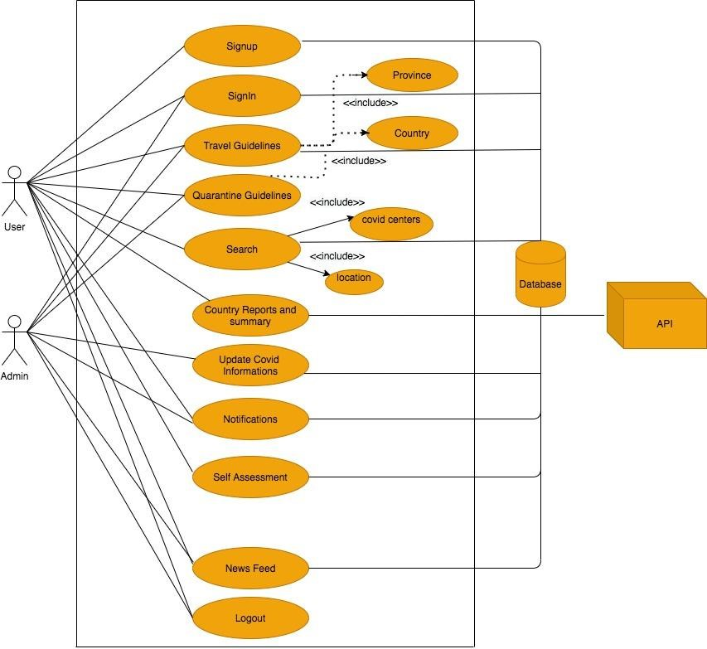

## User Stories

|  |  |
| --- | --- |
| **User story Id** | CA-01 |
| **Name** | As a user, I want to enter my email and password so that I can login into my Covid Application. |
| **User story points** | 5 |
| **Priority** | Medium |
| **Description** | When a user wants to access the covid Application, the user first needs to enter email and password if already registered. |

|  |  |
| --- | --- |
| **User story Id** | CA-02 |
| **Name** | As a user, I want to register first to covid Application with an app so that I can login. |
| **User story points** | 5 |
| **Priority** | Medium |
| **Description** | When a user wants to access the covid Application. Users need to register with email, name, password, and confirm password. |

|  |  |
| --- | --- |
| **User story Id** | CA-03 |
| **Name** | As a user, I want to reset my password |
| **User story points** | 3 |
| **Priority** | Low |
| **Description** | The user will be able to reset the password |

|  |  |
| --- | --- |
| **User story Id** | CA-04 |
| **Name** | As a user, I want to view the travel guidelines |
| **User story points** | 13 |
| **Priority** | High |
| **Description** | The user will be able to view the travel guidelines |

|  |  |
| --- | --- |
| **User story Id** | CA-05 |
| **Name** | As a user, I want to view the Quarantine guidelines |
| **User story points** | 13 |
| **Priority** | High |
| **Description** | The user will be able to view the Quarantine guidelines |

|  |  |
| --- | --- |
| **User story Id** | CA-06 |
| **Name** | As a user, I want to search the covid test centres |
| **User story points** | 8 |
| **Priority** | Medium |
| **Description** | The user will be able to search the covid test centres |

|  |  |
| --- | --- |
| **User story Id** | CA-07 |
| **Name** | As a user, I want to view the covid test centres |
| **User story points** | 8 |
| **Priority** | High |
| **Description** | The user will be able to view the covid test centres |

|  |  |
| --- | --- |
| **User story Id** | CA-08 |
| **Name** | As a user, I want to view the country wise reports and summary |
| **User story points** | 13 |
| **Priority** | High |
| **Description** | The user must be able to view the country wise summary related to the covid |

|  |  |
| --- | --- |
| **User story Id** | CA-09 |
| **Name** | As a user/admin, I want to able to view the notifications related to covid |
| **User story points** | 8 |
| **Priority** | High |
| **Description** | The user/Admin must be able to receive the notifications related to the covid |

|  |  |
| --- | --- |
| **User story Id** | CA-10 |
| **Name** | As a user i want to able to perform self assessment |
| **User story points** | 8 |
| **Priority** | High |
| **Description** | The users must be able to self Assess for covid using the application guidelines |

|  |  |
| --- | --- |
| **User story Id** | CA-11 |
| **Name** | As a user i want to able to view the news feed |
| **User story points** | 5 |
| **Priority** | Medium |
| **Description** | The users must be able to view the news feed |

|  |  |
| --- | --- |
| **User story Id** | CA-12 |
| **Name** | As an admin i should be able to add the information related to covid |
| **User story points** | 8 |
| **Priority** | High |
| **Description** | The admin can able to add the information related to covid |

|  |  |
| --- | --- |
| **User story Id** | CA-13 |
| **Name** | As an admin i should be able to update the information related to covid |
| **User story points** | 5 |
| **Priority** | Medium |
| **Description** | The admin can able to update the information related to covid |

|  |  |
| --- | --- |
| **User story Id** | CA-14 |
| **Name** | As an admin i should be able to delete the information related to covid |
| **User story points** | 5 |
| **Priority** | Medium |
| **Description** | The admin can able to delete the information related to covid |

|  |  |
| --- | --- |
| **User story Id** | CA-15 |
| **Name** | As an admin i should be able to logout of the covid application |
| **User story points** | 3 |
| **Priority** | low |
| **Description** | The admin can able to logout of the covid application |

## User Story Backlog

|  |  |  |  |
| --- | --- | --- | --- |
| ID | Name | USP | Priority |
| CA-1 | As a user, I want to enter my email and password so that I can login into my Covid Application. | 5 | Medium |
| CA-2 | As a user, I want to register first to covid Application with an app so that I can login. | 5 | Medium |
| CA-3 | As a user, I want to reset my password | 3 | Low |
| CA-4 | As a user, I want to view the travel guidelines | 13 | High |
| CA-5 | As a user, I want to view the Quarantine guidelines | 13 | High |
| CA-6 | As a user, I want to search the covid test centres | 8 | High |
| CA-7 | As a user, I want to view the covid test centres | 8 | High |
| CA-8 | As a user, I want to view the country wise reports and summary | 13 | High |
| CA-9 | As a user/admin, I want to able to view the notifications related to covid | 8 | High |
| CA-10 | As a user i want to able to perform self assessment | 8 | High |
| CA-11 | As a user i want to able to view the news feed | 5 | Medium |
| CA-12 | As an admin i should be able to add the information related to covid | 8 | High |
| CA-13 | As an admin i should be able to update the information related to covid | 5 | Medium |
| CA-14 | As an admin i should be able to delete the information related to covid | 5 | Medium |
| CA-15 | As an admin i should be able to logout of the covid application | 3 | Low |
|  |  | Total USP =110 |  |

## Release plan-1

|  |  |  |
| --- | --- | --- |
| S.no | User ID | Release date |
| 1 | CA-1 | 5th  July 2021 |
| 2 | CA-2 | 5th  July 2021 |
| 3 | CA-3 | 5th  July 2021 |
| 4 | CA-5 | 5th  July 2021 |
| 5 | CA-12 | 5th  July 2021 |
| 6 | CA-15 | 5th  July 2021 |
| TOTAL USP | 37 |  |

## Release plan-2

|  |  |  |
| --- | --- | --- |
| S.no | User ID | Release date |
| 1 | CA-4 | 2nd August 2021 |
| 2 | CA-9 | 2nd August 2021 |
| 3 | CA-11 | 2nd August 2021 |
| 4 | CA-13 | 2nd August 2021 |
| 5 | CA-14 | 2nd August 2021 |
| TOTAL USP | 36 |  |

## Release plan-3

|  |  |  |
| --- | --- | --- |
| S.no | User ID | Release date |
| 1 | CA-6 | 16th August 2021 |
| 2 | CA-7 | 16th August 2021 |
| 3 | CA-8 | 16thAugust 2021 |
| 4 | CA-10 | 16thAugust 2021 |
| TOTAL USP | 37 |  |

## Poker Planning

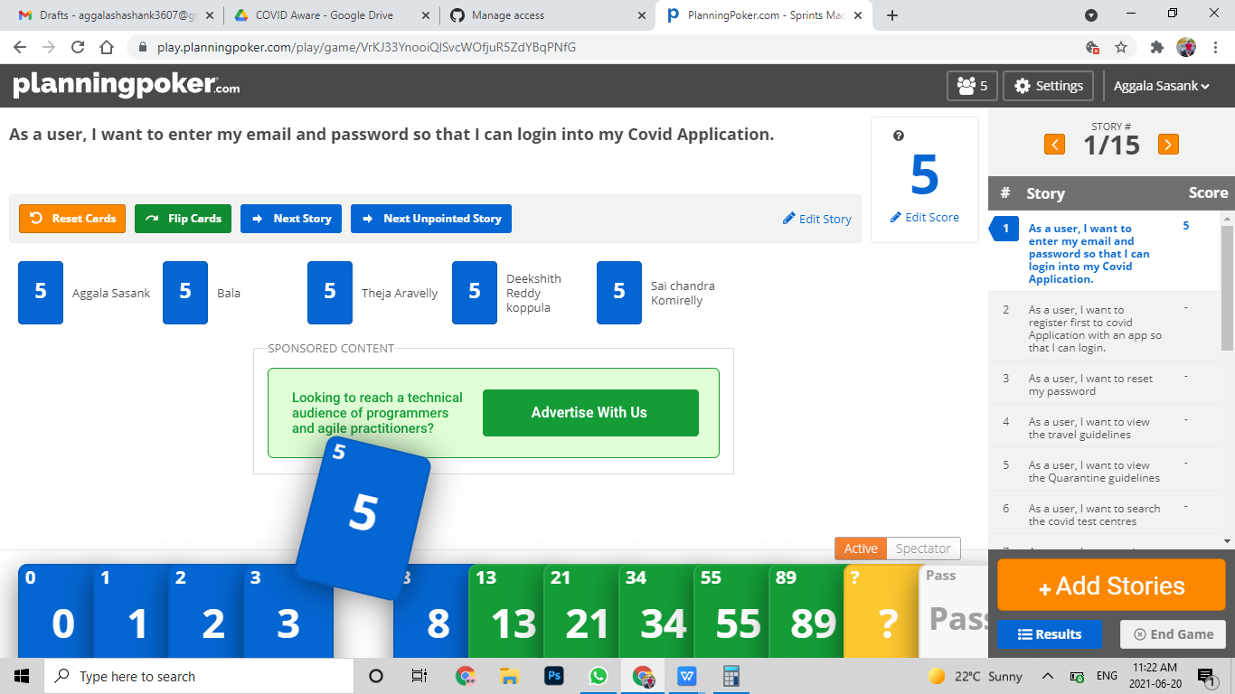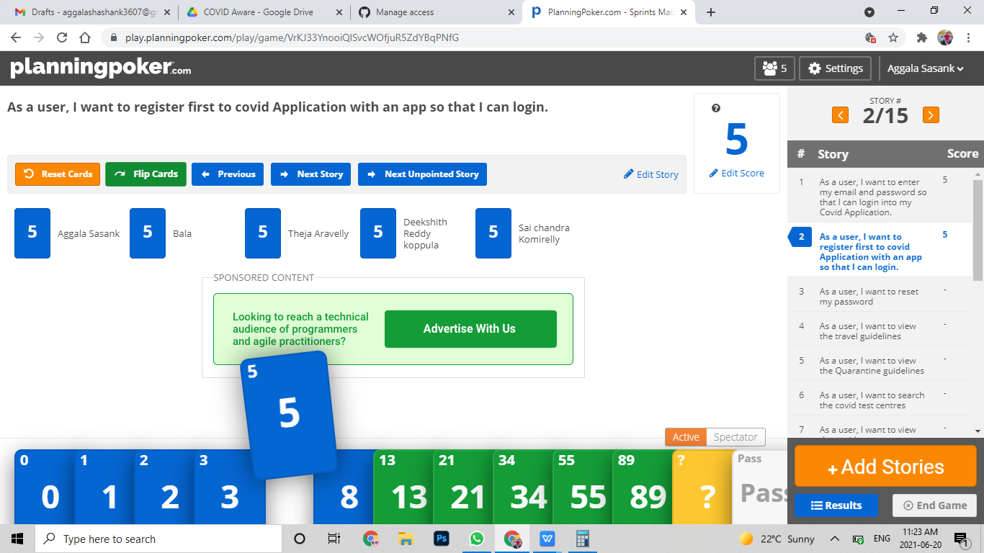

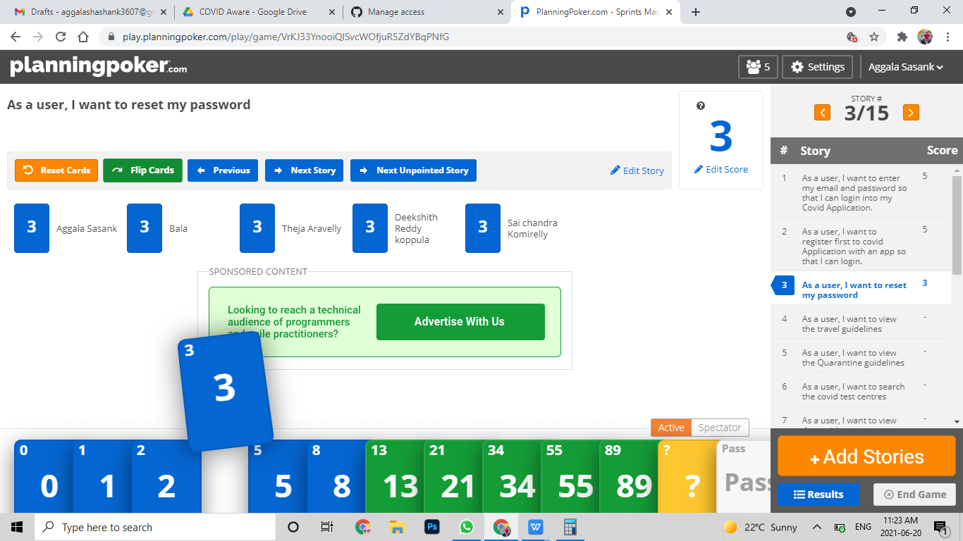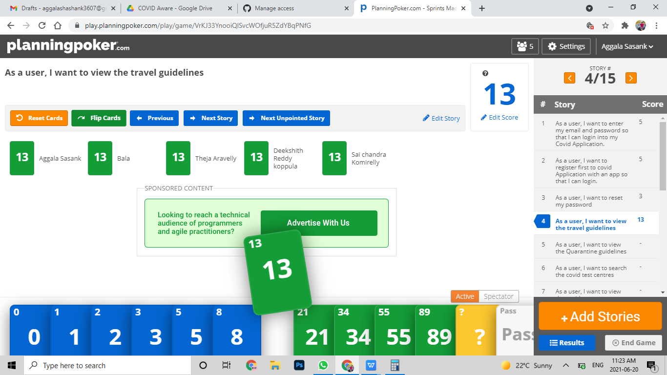

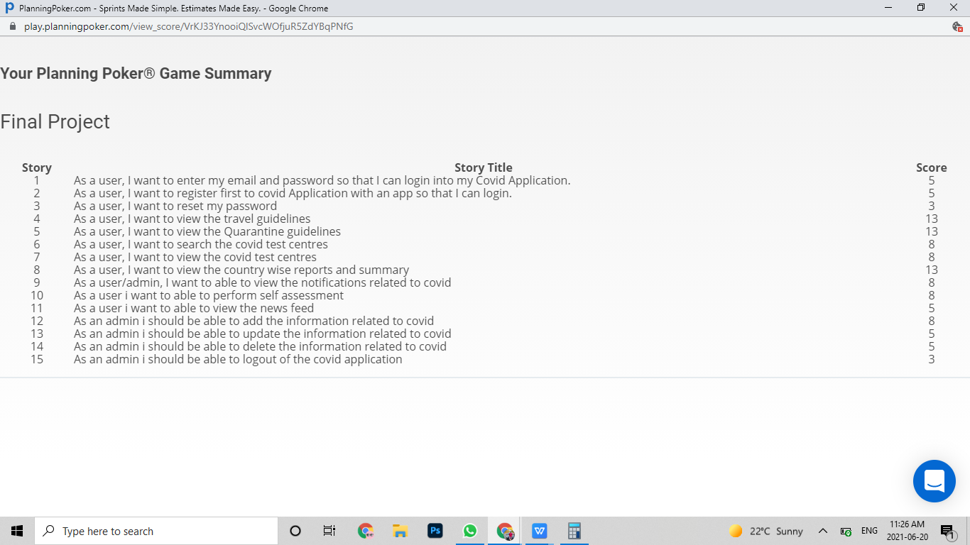

1. **Mockups**

Splash screen



Login screen

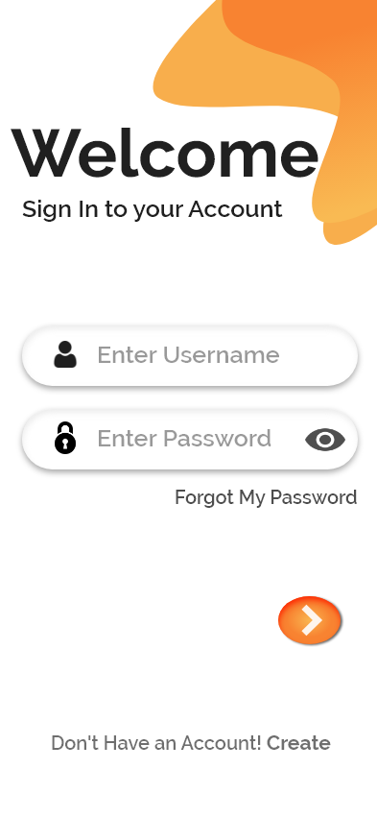

1. Registration Screen

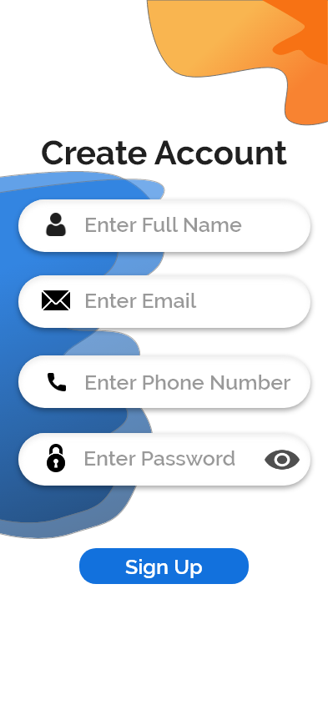

1. Reset Password

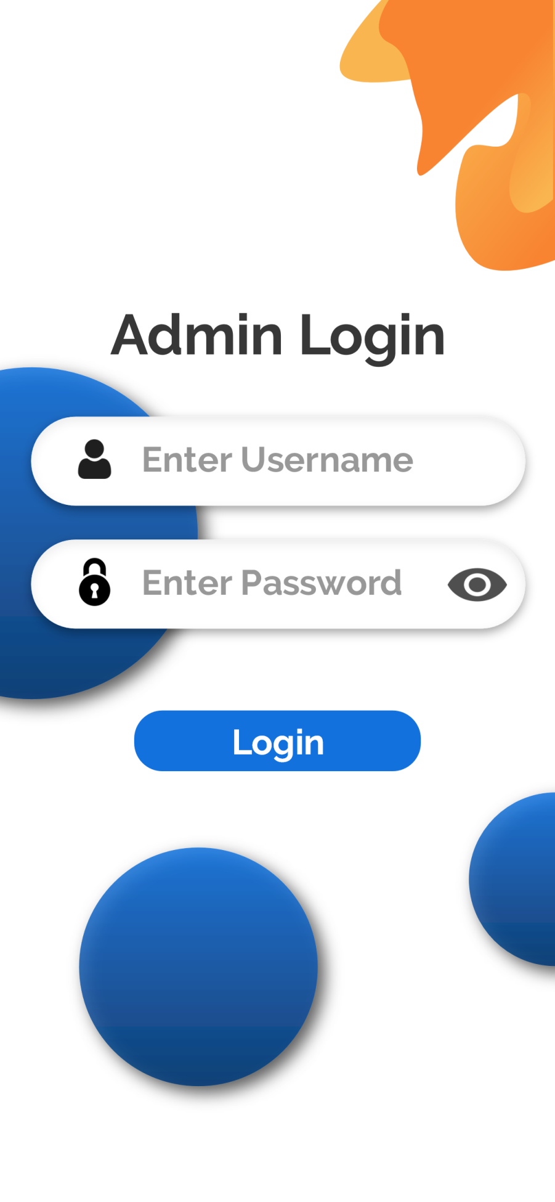

1. Admin Home

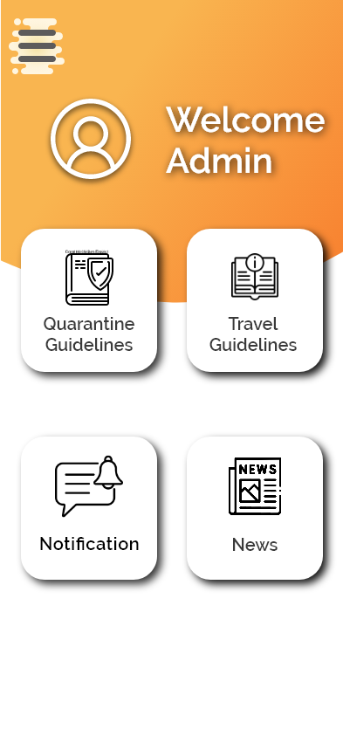

1. Admin Navigation

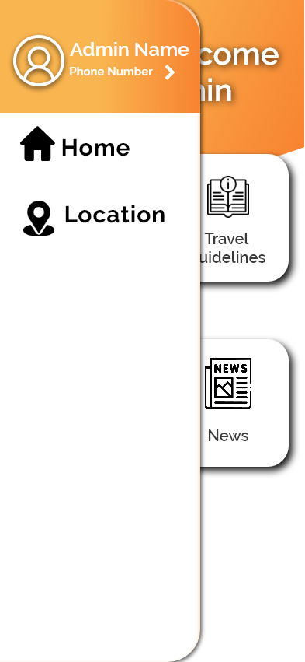

1. Quarantine Guidelines

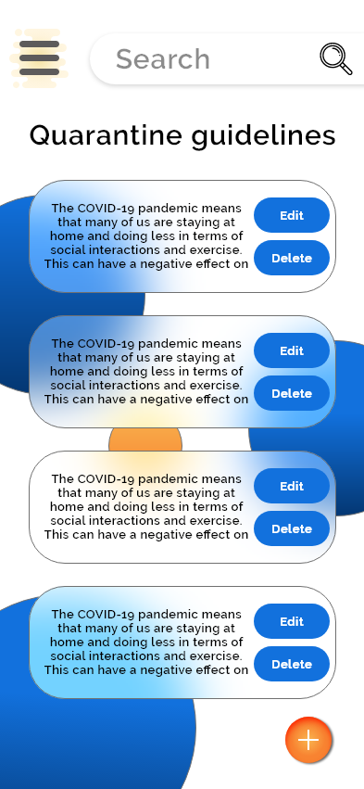

1. Add Quarantine Guidelines

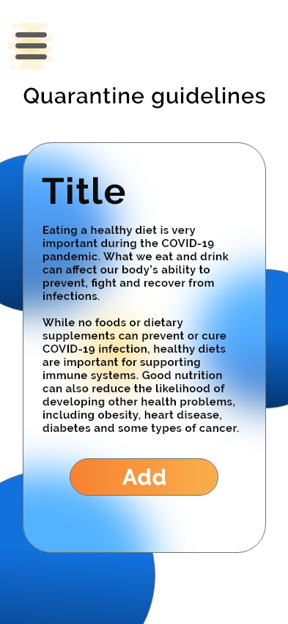

1. Travel Guidelines

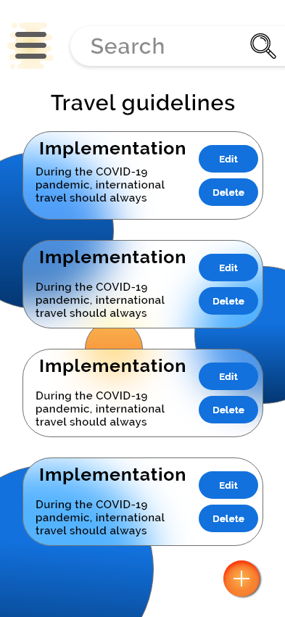

1. Add Travel Guidelines

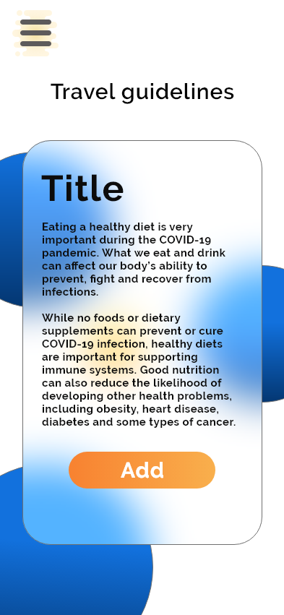

1. Admin News screen

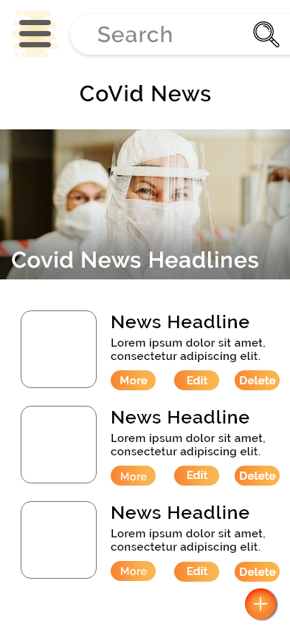

1. Admin News edit

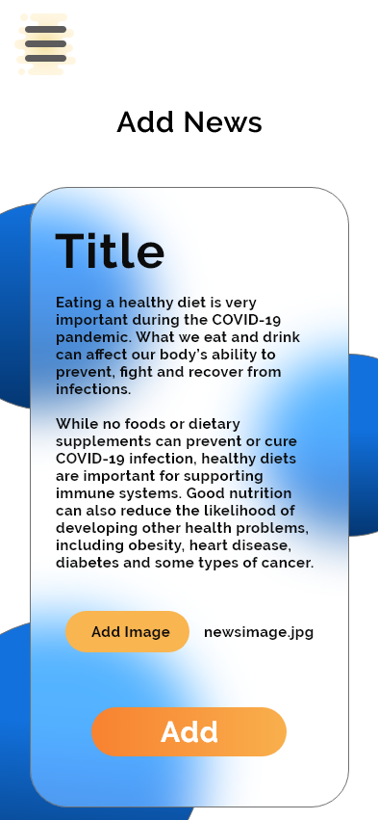

1. Admin Notification

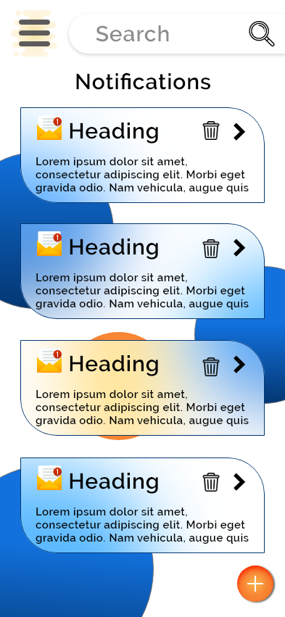

1. Admin notification edit

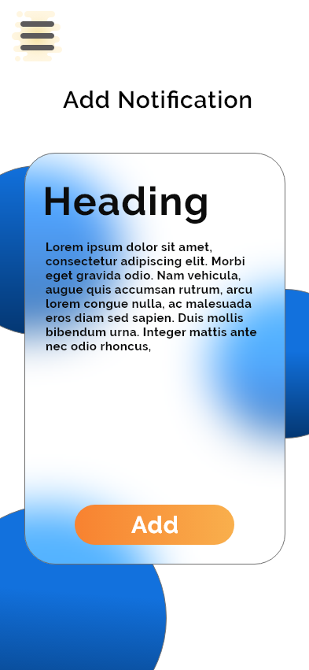

1. Admin Covid Centres

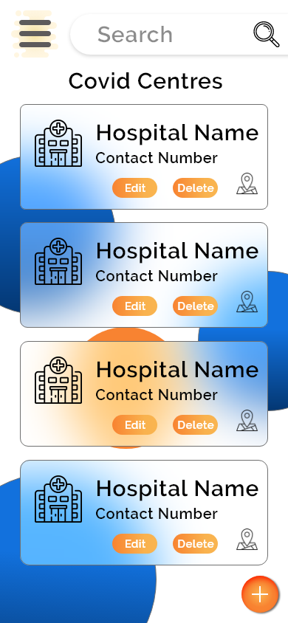

1. Admin Edit covid centres

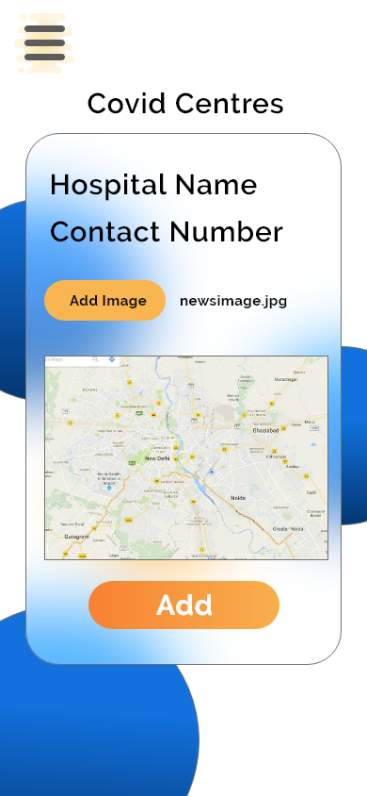

1. User Home

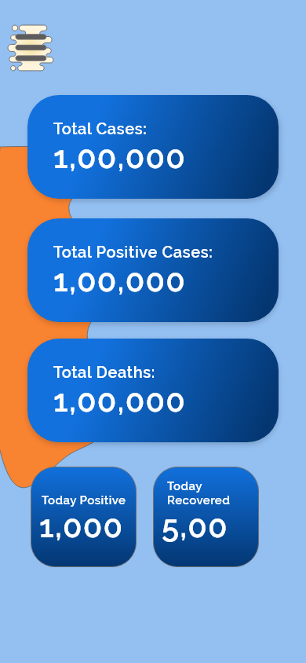

1. User Navigation

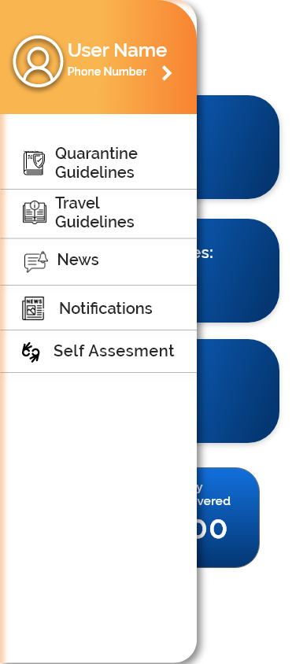

1. Quarantine Guidelines for user

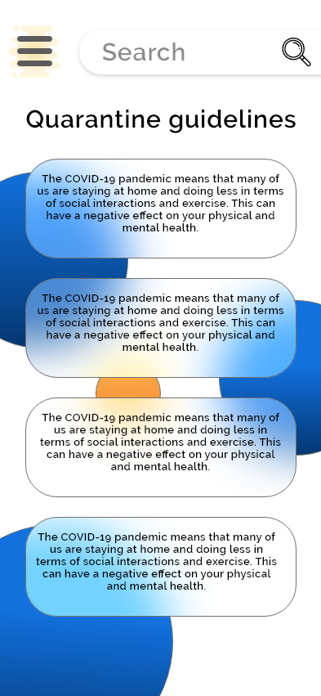

1. User Guidelines View

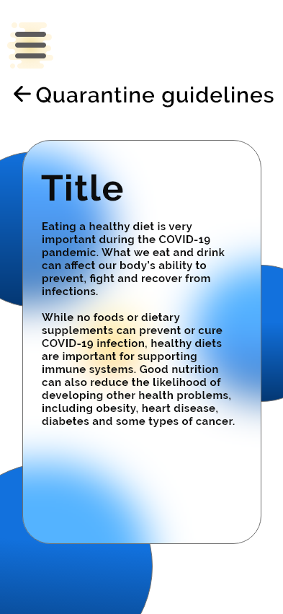

1. Travel Guidelines for User

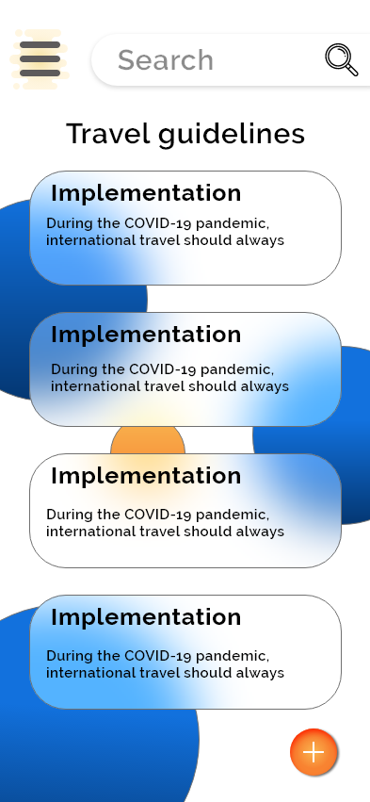

1. Travel Guidelines View

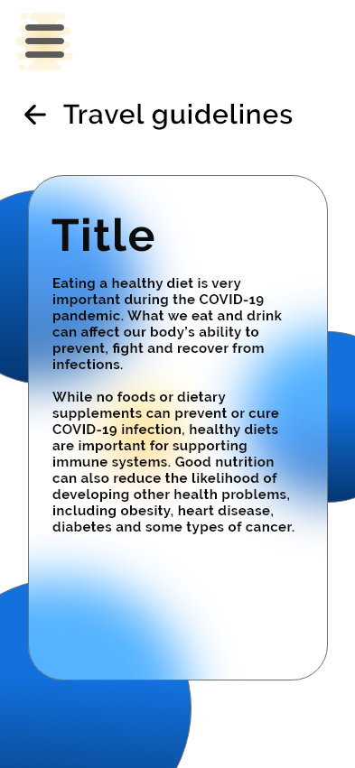

1. User News

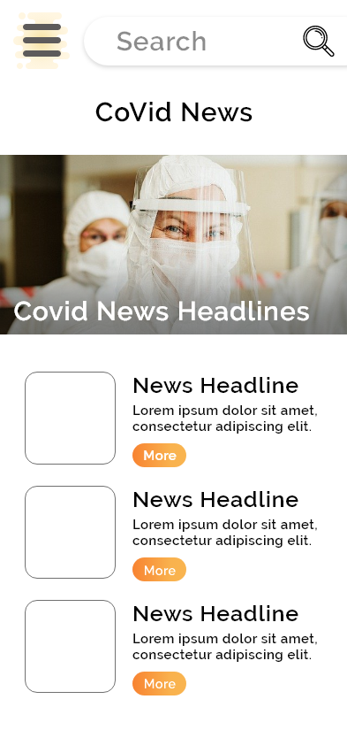

1. User News view



1. User Notification



1. User Notification view

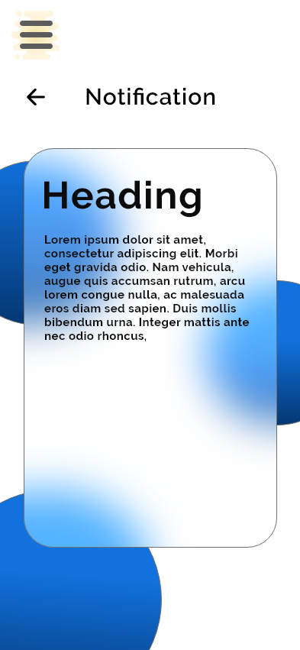

1. User Self-Assessment

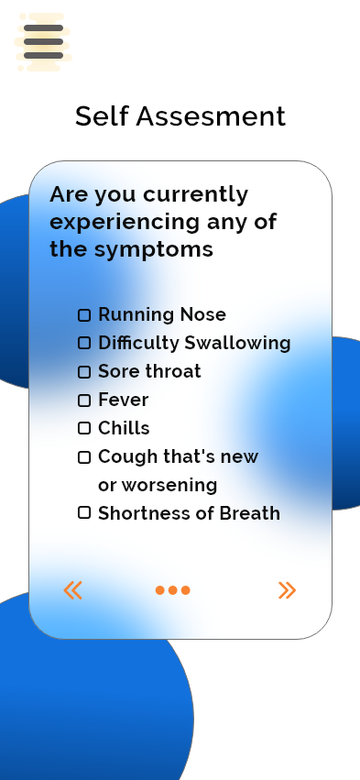

1. User Covid Centres

